**Management portal bug list:**

1. Reports-State tax-For specific tails like, 105ST,109CH,119JE,121GZ,12260,131YF, after select any one of these tails and select “Jan/2021” in from month and select “Jan/2022” in to month and click view button details are displayed and no alert message is displayed. This issue occurs only select the above mentioned tails only.

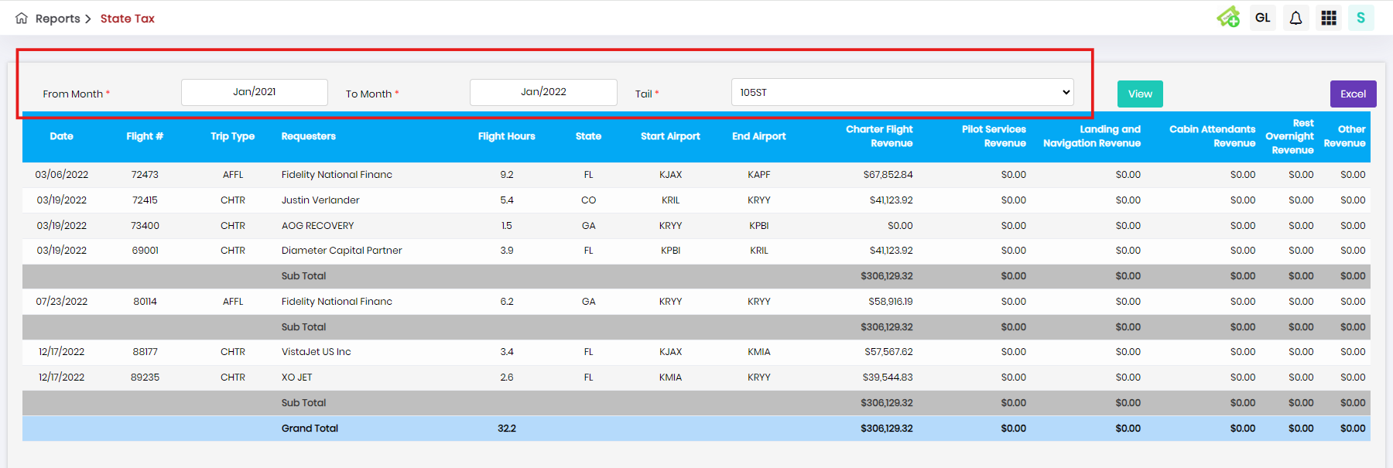

1. MS-Report-Prepare MS Report-After select any tail(I have select 807LA Tail) and click edit button, In hide transcation and Expense Attach Invoice tab, for aircraft miscellaneous expense, previous month details also displayed.

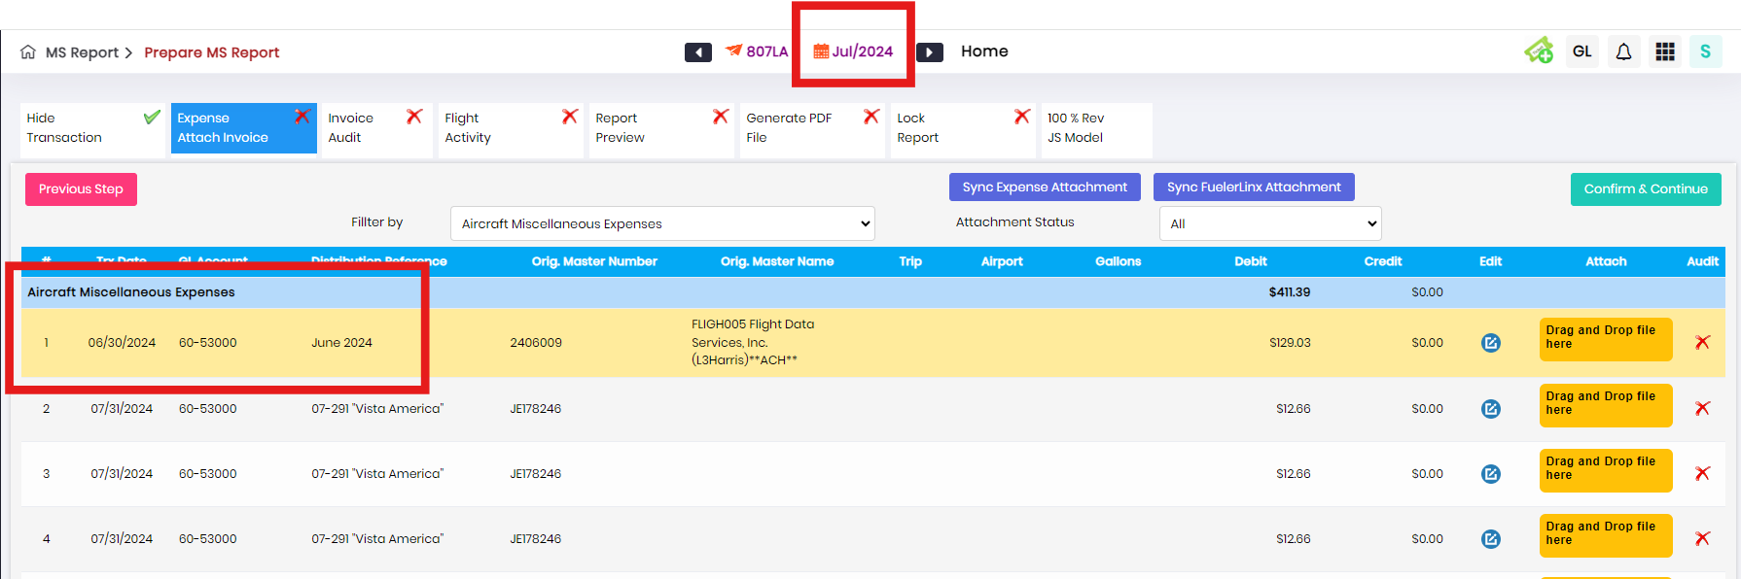

1. MS-Report-Prepare MS Report-After select any tail(I have select 109CH Tail) and click edit button,

In Revenue owner pay tab, after click attach button in ORA or Quote column, after upload valid file in ORA Agreement tab only and click save button. Then again click attach button in Quote column and upload valid file in Quote agreement tab and click save button, previous uploaded file is removed in ORA column automatically.

First Upload:

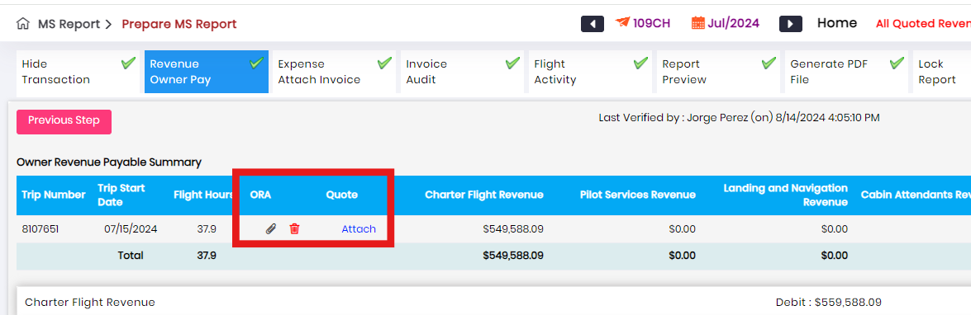

Second Upload:

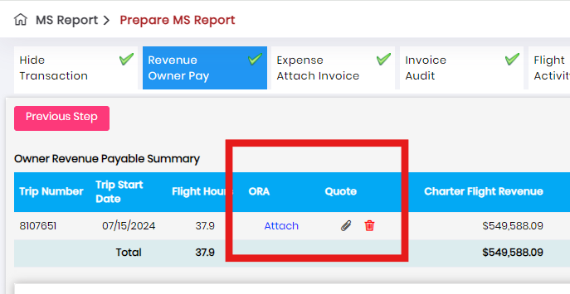

1. MS-Report-Prepare MS Report-After select any tail(I have select 109CH Tail) and click edit button, In Generate PDF File tab, Click Regenerate MS Report, system generated report radio button and click system generated radio button and as well as manual upload radio button, then enter valid details and click “Click to generate” button, invalid error toast.

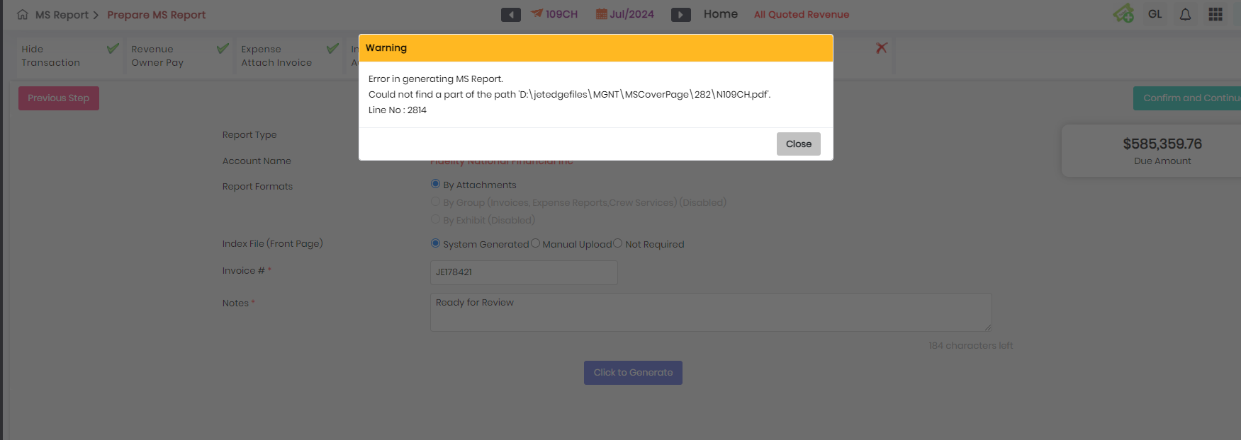

1. MS-Report-Prepare MS Report-After select any tail(I have select 109CH Tail) and click edit button, in lock report tab, without enter any details in notes field and click lock report error toast is appeared but spelling is wrong.

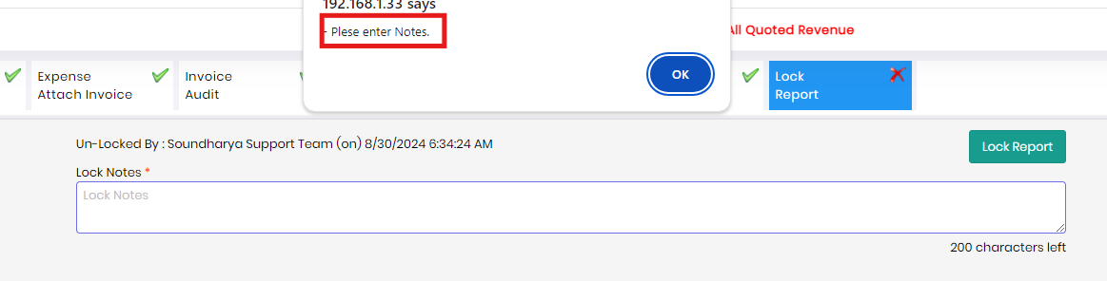

1. MS-Report-Prepare MS Report-After lock the report in any tail but user can able to update the data in any tab.
2. Owner portal-Owner setup-Click add owner- Tail mapping should be mandatory status.

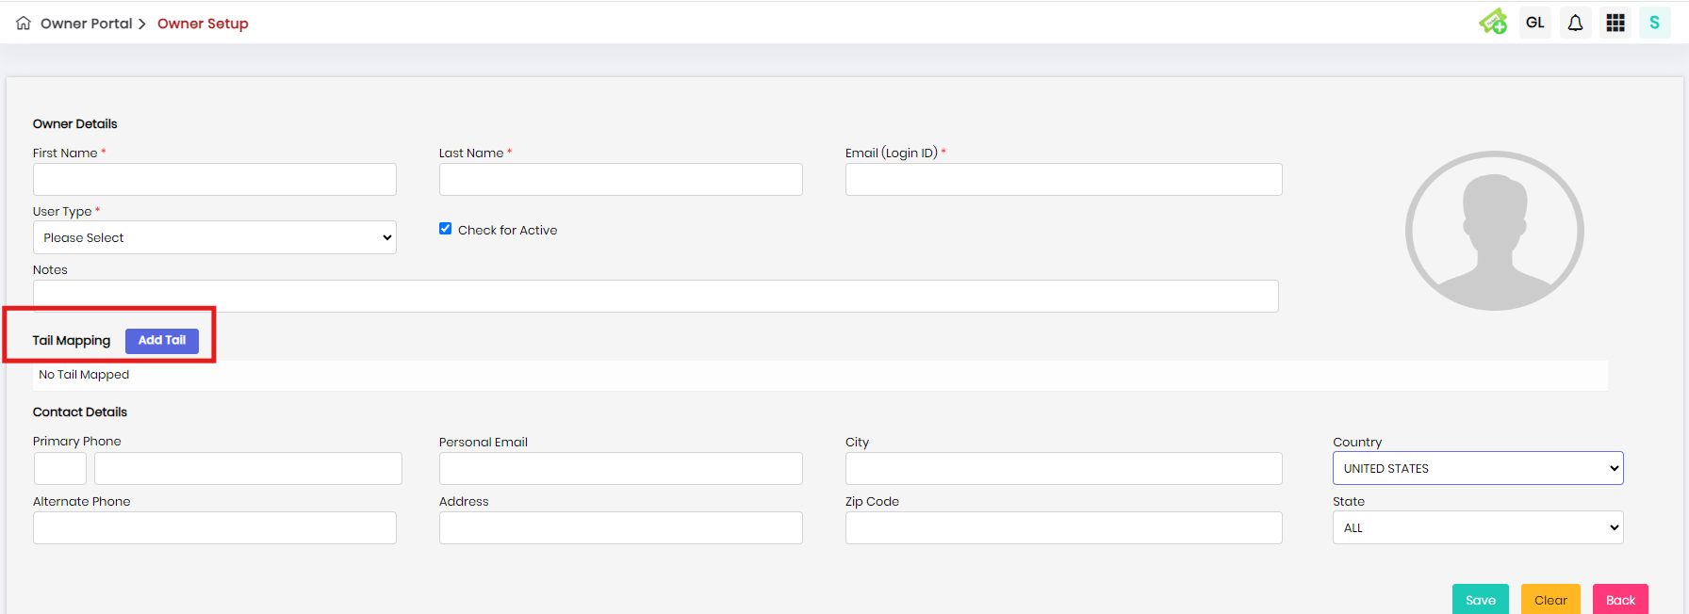

8.